**Brooklyn torah gazette**

**For parshas devorim 5782**

Volume 6, Issue 45 (Whole Number 300) 9 Menachem Av 5782/ August 6, 2022

**Rav Yitzchok Tuvia Weiss, zt”l**

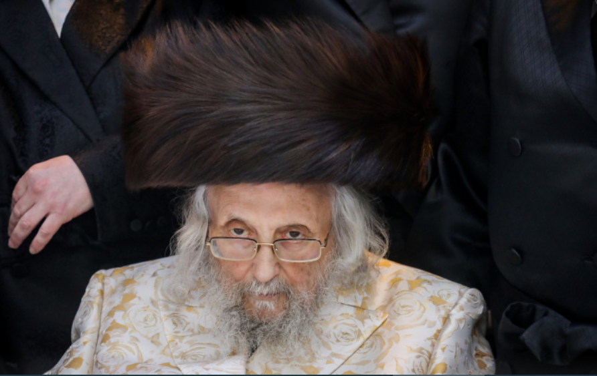

It is with great sadness that ***Matzav.com***reports the *petirah* of Rav Yitzchok Tuvia Weiss *zt”l, gaon av bais din* of the *Badatz* of the Eidah Hachareidis of Yerushalayim. He was 96. Rav Weiss was *niftar* on Friday night at Hadassah Ein Kerem Medical Center in Yerushalayim.

Born in August 1926 in Slovakia, he was a son of R’ and Mrs. Shlomo Weiss. Rav Tuvia attended the local secular school in the mornings and learned with a private *melamed* in the afternoons.

Before World War II, he escaped Slovakia on a Kindertransport, leaving his parents and family behind. He arrived with the Kindertransport in London in late May of 1939, after *Shavuos*.

He celebrated the *Shabbos* of his *bar mitzvah* at the home of a British woman who took him in. The only *sefer* he received for his *bar mitzvah* was a copy of the *Kitzur Shulchan Aruch*, which he studied for many weeks until he mastered it. He also received a pair of *tefillin*, sent to him from his father through the Red Cross before he was murdered. By the time the *tefillin* arrived, neither of his parents were alive.

He continued his learning at Yeshivas Toras Emes in Stamford Hill, London, also known as Schneider’s Yeshiva, where he learned under Rav Moshe Yehuda Schneider. One of his peers at the *yeshiva* was Rav Moshe Sternbuch, *raavad* of the Eidah Hachareidis today.

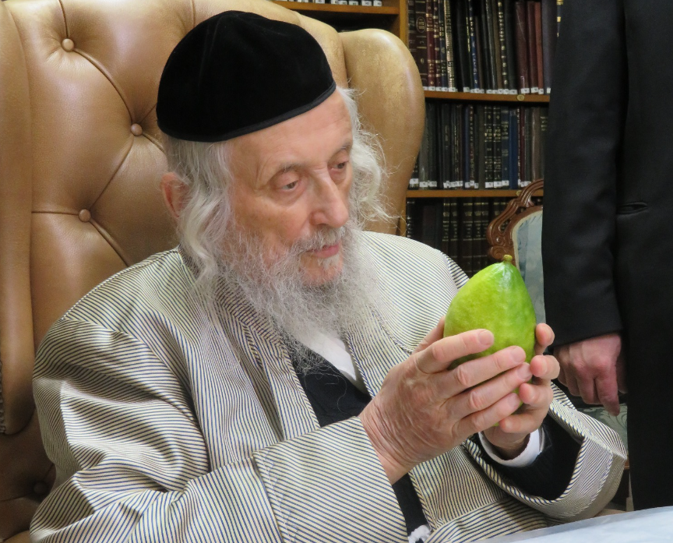

After his marriage, he learned at the Gateshead Kollel under Rav Eliyahu Eliezer Dessler, who served as *rosh kollel.*

A few years later, Rav Weiss moved to London, where he was hired as a *maggid shiur* at a *yeshiva*, and as a *posek* and *rav* of a *shul*. Later, he moved to Antwerp, where he served as a *maggid shiur* at the *yeshiva* in Wilrijk, and where he was appointed *dayan* in 1967.

He became *gaavad* of the Eidah Hachareidus in Yerushalayim in 2004.

The *levayah* is slated to took place at on Sunday morning at the headquarters of the Eidah Hachareidis in Yerushalayim, followed by *kevurah* on Har Hazeisim (the Mount of Olives).

*Yehi zichro boruch.*

*Reprinted from the July 31, 2022 website of Matzav.com*

**The Proper Way to Help Secular Jews and How to Avoid the Influence of Non-Jews**

**By Daniel Keren**

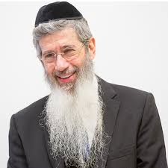

The first speaker at the recent July 4th Hakhel Yarchei Kallah program in Flatbush was Rabbi Dovid Goldwasser, internationally renowned Marbitz Torah and author spoke on the topic of “Halachic Perspectives for Our Times.” He began by recalling the recent petirah (death) of Rav Uri Zohar who was a prominent Israeli baal teshuvah who went on to inspire many other Israelis in the last half century to likewise become baalei teshuvah, coming closer to a Torah way-of-life.

Rabbi Goldwasser pointed out that the legacy of Rav Zohar who had been a famous entertainer before giving up that lifestyle in order to enjoy a Torah lifestyle and influencing others to follow in his footsteps highlights the important responsibility for each and everyone of us to be an inspiration for others who are far from the Torah.

Rav Avigdor Miller said that if one gets a mortgage for a nice house or rents an apartment, one should know that this was arranged by Hashem in order to allow that person or family the precious and perhaps spiritually life-saving opportunity to help a neighbor come closer to Hashem and His Torah.

**Can One Utilize “Heterim” to Achieve the Greater Good**

Rabbi Goldwasser addressed the question of whether one is permitted to utilize “hetaerism” (special exemptions) in order to achieve the greater good of inspiring others to do teshuvah (become a Torah observant Jew)? For example, can one invite someone to their home for a Leil Shabbos (Friday night) seuda (meal) if that would most likely entail a desecration of Shabbos by resulting in the “guest” driving or taking public transportation in order to return home.

Rabbi Goldwasser said that this is a dangerous heter and one should not invite such a guest if that would result in the desecration of Shabbos. Even if one offers the guest the option to sleep over, if one doesn’t know if the offer will be accepted, many rabbonim are not that happy with making such a Leil Shabbos invitation.

Another related issue is that if you are successful in persuading another Jew who is not frum (religiously observant) to become interested in Yiddishkeit, one should be very careful when it comes to offering specific guidance.

For example, if the person you are positively influencing is 40-years-old, when informing him or her of the mitzvah obligation to give maisa (10% of your after-tax income) one should be careful to explain that the person is not obligated to give maisa for all of the income that he or she had earned during the past 15 or 20 years. Indeed, such an endeavor might be too difficult for the budding baal teshuvah and that could even (G-d forbid) cause him or her to despair and result in their abandoning their interest in coming closer to Hashem and a Torah way-of-life.

**The Same Formula Also Applies to Other Mitzvahs**

Indeed, Rabbi Goldwasser suggested that the person he is inspiring to just simply make the commitment from this moment on going forward to be meticulous in the performance of this special mitzvah. And this same formula also applies to the other Taryag (613) mitzvahs that you teach your friend about and encourage him or her to do.

A person never knows what he truly needs. One can daven (pray) sincerely for something that he desires which if he or she gets would unfortunately be very destructive to him or her in both the realms of gashmius (physical or material needs) and ruchnius (spiritual endeavors).

Rabbi Goldwasser focused on the important co guarding one’s eyes. He noted that what is before our eyes exerts a great influence on a person. If we pay attention to baseball or basketball “stars” for their athletic excellence, it would be impossible for us as a Yid to be immune to the devastating influence on our pure neshamas (souls) as a result of also discovering their immoral and arrogant lifestyles.

Similarly, Rabbi Goldwasser told the Hakhel audience that we have to be very careful about what music we listen to. The Talmud teaches us that Elisha ben Abuya was a great Torah scholar and a primary teacher of Rebbi Meir. Yet he went off the derech (abandoned a Torah way-of-life) despite his brilliance in Torah knowledge.

**The Danger of Greek (Non-Jewish) Music**

When he was questioned as to why he lost his faith, Elisha ben Abuya confessed that he had allowed himself to listen to Greek (non-Jewish) music that lacked Torah values. Today, Rabbi Goldwasser warned we have to know that the immoral non-Jewish music of today like rock and roll music has the same nefarious power to distract and take a person away from the kedushah (the holiness) of Torah Judaism. Even the catchy tunes of non-Jewish music when adapted to Torah lyrics can have a negative influence on a Yid (Jew).

Looking into the eyes of a tzadik (righteous Jew) will exert a powerful and beneficial influence on a Jew. How much more careful must one be to avoid gazing into the eyes of a rasha (a wicked, evil, immoral person) regardless of whether or not that individual is a Jew or gentile.

*Reprinted from the July 28, 2022 edition of The Flatbush Jewish Journal.*

**Created in G-d’s Image**

Rabbi Akiva used to say: Beloved is man, for he was created in the image of G-d; but it is by a special love that he was informed that he was created in the image of G-d (Ethics 3:14)

G-d created man in His image, charging him, by virtue of his intellect, with dominance over the rest of creation. This is reflected in the fact that human beings walk erect with head held high, whereas all other creatures, whose source is earthly, walk on all fours looking down. *(Midrash Shmuel)*

*Reprinted from the Parshat Devorim 1997/5757 (Issue #480) edition of L’Chaim Weekly*

**Rav Avigdor Miller on**

**Russia Trumps America**



**QUESTION: If it’s true what you said that the wicked are naturally punished in this world, so how is it that Russia is gaining power?**

**ANSWER:** And the answer is that, surprising as it may seem, Russia has become one of the best places in the world to live. It’s surprising to us but a lot of people in other countries are thinking of moving to Russia. Because in Russia in all the cities you can walk out on the street at midnight.

**The Punishment of Criminals is**

**An Important Function of Society**

Now the fact that they have repressions there and they don’t permit strikes and many other things that you don’t like, that doesn’t necessarily mean that they’re bad.  Don’t forget that the punishment of criminals is one of the biggest functions of a decent society and when this is neglected then that society has incurred a great penalty for itself. In Russia they still punish criminals. America on the other hand is under great, I don’t want to say it but chas veshalom we are under great blame for the wickedness that it permits.

When a society permits degenerates to parade in public it loses its rights. And in Russia you don’t have such displays of immorality like you have in America.  And therefore there are many positive virtues in a society that maintains old-fashioned attitudes.

**There are Plenty of Athiests in this County**

Now you’ll say that at least America is not atheistic like Russia is. But don’t forget there are plenty of atheists in this country and they’re the ones who are today running the public school system.  The whole educational system is in the hands of atheists here. So what are they better than Russia?  Only that these American atheists are teaching the children to disregard their parents, to do whatever they want, to be homosexuals and revolutionaries, and not to work.

Whereas in Russia they’re taught to work. In Russia work is a big virtue.  When Russian boys come here, they may be ignorant of Yiddishkeit, but they’re not wild; they’re not corrupt.  They’re decent citizens.  All they need is Yiddishkeit but as people they’re to be desired.  Desirable people come from Russia. You have to know that a Russian ordinary person, even a gentile and lehavdil surely the Jew, are fine people because they’re not allowed to run wild.  
Of course we prefer liberty but who says that liberty has produced the best results?  It has produced a San Francisco which is a haven for rodents, for reptiles. So what’s so good about America?  All the liberty in America is being misused.

So therefore it’s not a big kasha why Russia is gaining the upper hand today.

*Reprinted from July 19, 2022 email of Toras Avigdor. Adapted from Tape #314 (June 1980)*

**The Jewish and Ancient Greek Views of Wisdom**

Rabbi Chanina Ben Dosa used to say: Anyone whose deeds are more than his wisdom, his wisdom will endure; anyone whose wisdom exceeds his deeds, his wisdom will not endure (Ethics 3:12)

The Jewish view of wisdom is essentially different from that of the ancient Greeks. According to Aristotle, the function of man, his highest virtue and his ultimate purpose are the attainment of the contemplative life, the exercise of reason. But for the Jew, wisdom and knowledge are only the means to an end. "Great is study because it leads to action," states the Talmud. No one in the throes of hunger has ever benefitted from another's high thoughts alone. Jewish thought requires "fruit "-- tangible accomplishment in the real world, practical achievements in reforming the heart of man. *(Ethics From Sinai)*

*Reprinted from the Parshat Devorim 1997/5757 (Issue #480) edition of L’Chaim Weekly*

**The Significance of the “Plains of Moab” and**

**“This Side of the Jordan”**

**From the Talks of the Lubavitcher Rebbe**

**Rabbi Menachem Mendel Schneerson, Zt”l**

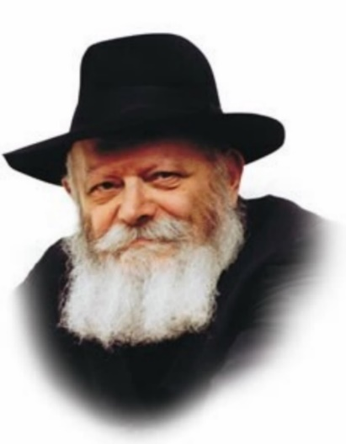

This week's Torah reading, Devarim, is the first portion in the Book of Devarim (Deuteronomy). The entire book was related to the Jewish people in their 40th year in the desert. By that time, the majority of the Jews who had left Egypt were no longer alive; only those who would enter the land of Israel were alive. Thus the Book of Devarim was intended as a preparation to help them make this transition.

**“These are the Words which Moses Spoke…”**

Devarim begins by noting the location of the Jews' final encampment before entering Israel. "These are the words which Moses spoke...on this side of the Jordan." At the end of Bamidbar (Numbers), however, this same place is referred to as "the plains of Moab, by the Jordan opposite Jericho."

"The plains of Moab" and "this side of the Jordan" are both names that describe the same physical location. And yet, each name has a different connotation:

"The plains of Moab" identifies the location by its connection to the land of Moab. "This side of the Jordan," by contrast, associates it with the land of Israel, identifying it as lying on the eastern shore of the Jordan river, with the rest of the land of Israel lying toward the west.

**Two Names for the Same Place**

What are we to learn from the Torah's usage of two names for the same place?

The Book of Devarim is essentially different from the Book of Bamidbar. Bamidbar relates the various encounters and experiences of the Jewish people during their 40 years in the desert. Devarim, however, relates Moses' exhortations to the generation that was about to enter Israel, as preparation for the new lives they would be leading there.

At the end of Bamidbar, the site of the Jews' encampment is referred to as "the plains of Moab," as it expressed their connection to a land whose status was non-Jewish territory.

In Devarim, however, it is referred to as "this side of the Jordan," for at that time, the Jewish people were focused on their imminent entry into the land of Israel.

We find ourselves now in the last minutes of exile, poised on the brink of the Final Redemption. Thus our present era is analogous to the one we read about this week.

**Our Preparation for Moshiach’s Imminent Arrival**

"The plains of Moab" is symbolic of the exile and its completion; "this side of the Jordan" is symbolic of our preparation for Moshiach's imminent arrival. Indeed, "this side of the Jordan" is a most appropriate name with which to characterize our present transitional period, for it corresponds to the Jews' heightened state of anticipation in the 40th year of their going out of Egypt.

Moshiach's coming is imminent. We must prepare to greet him. May it happen now.

*Reprinted from the Parshat Devorim 1997/5757 (Issue #480) edition of L’Chaim Weekly, a publication of the Lubavitch Youth Organization in Brooklyn, NY. Adapted from Likutei Sichot, Volume 2.*

**Rabbi Berel Wein on**

**Parshat Devarim 5782**

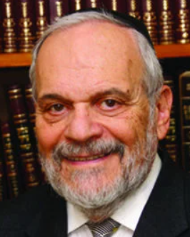

This week's Torah reading begins the oration by our teacher Moshe during the final months of his life. In this oration, he reviews the 40-year sojourn of the Jewish people in the Sinai desert, and prophesizes regarding their future, first in the Land of Israel. and then throughout history. The Torah tells us that Moshe began his speech when the Jewish people were located between certain landmarks in the desert of Sinai. Rashi, following the ideas of the Midrash, explains that the locations that were identified were not meant to be specific geographic localities, but were intended to highlight events that occurred to the Jewish people during their 40-years in the Sinai.

We have a rule that while there are myriad interpretations to the eternal words and to the depth of the narrative verses as written in the Torah, the Talmud cautions us that while we should always be aware what the Torah really means, the simple explanation of the words is primary to our understanding of the values and message of the Torah.

Therefore, the listing of these geographic locations where Moshe begins his oration to the Jewish people is an intrinsic value by itself. Moshe wants us to realize when, where, and under what circumstances the message and speech to the Jewish people is being delivered. By describing the place from which he is speaking, he is giving context and background to the message that he is attempting to deliver. All statements, no matter how profound and eternal, must be understood within the context of place and time.

It is difficult to communicate any message to a generation that is living miraculously in a barren desert. The audience must utilize imagination be able to deal with promises and issues concerning a country that they have never seen. It is also very difficult to speak to people about the future, which is so uncertain, and, to a great extent, mysterious. But Moshe’s oration addresses both these concerns.

He wants the listener to know that he is speaking from the desert, but that his message is also for the future of the Jewish people in the Land of Israel, when they settle the land***.*** And Moshe also looks far into the future, warning them of destruction and exile, horrendous events, but the eventual redemption and hope.

The greatness of Moshe is that he can speak in the present, from a place of identifiable geographic location, and project a message that will last for thousands of years. It will be valid and vital wherever one finds oneself on this planet. This is what makes Moshe the greatest of all prophets of the Jewish people, in all areas of life and faith, and for all eternity.

Shabbat shalom

*Reprinted from the current website of rabbiwein.com*

**Thoughts that Count for Our Parsha**

Everything is for the preponderance of (good) deeds (Ethics 3:15)

The number of times that a person performs a positive act is significant, therefore it is preferable to give charity in the form of many different gifts rather than in one lump sum of the same amount. By giving repeatedly, a person ingrains the trait of generosity in his character. *(The Lubavitcher Rebbe)*

Where there is no flour, there is no Torah; where there is no Torah, there is no flour (Ethics 3:17)

Flour (bread) is food for the body; Torah is sustenance for the soul; both are necessary to sustain the Jew properly. Each type of nourishment complements the other, for when one is lacking, the other suffers as well. *(Maharal of Prague)*

*Reprinted from the Parshat Devorim 1997/5757 (Issue #480) edition of L’Chaim Weekly*

**Former Gan Israel Camper Saved From Cremation**

**By**[**Menachem Posner**](https://www.chabad.org/search/keyword_cdo/kid/12145/jewish/Posner-Menachem.htm)



**Candice (Shoshana bat Yosef) of blessed memory**

The funeral took place at the Bnai Israel Jewish cemetery in Norfolk, Va.

Candice spent much of her 50-something years in a non-Jewish environment.

But she clung to the Jewish observances she gained as a child at Camp Gan Israel Day Camp in Richmond, Va., saying [Shema every night](https://www.chabad.org/library/article_cdo/aid/629832/jewish/Bedtime-Shema.htm), [lighting candles](https://www.chabad.org/library/article_cdo/aid/87131/jewish/How-to-Light-Shabbat-Candles.htm) before Shabbat and observing [the holidays](https://www.chabad.org/holidays/default_cdo/jewish/holidays.htm) to the best of her ability.

She had little in the way of material possessions, says her sister Suzie, “but she never saw the bad in anyone. Her home was literally open 24/7 to anyone in need, including children from unimaginably difficult home lives. They knew they were safe with her.”

**Husband Opted for Cremation**

When she passed away earlier this month, her husband decided that she would be cremated and sent her body to a non-Jewish funeral home with the expectation that the process would take a few days. A close friend of hers, Shannan, believing that the cremation had already been done, knew that she was Jewish and wanted to know if there were specific Jewish rites or prayers that should be performed upon retrieving the remains.

She reached out to Rabbi Chaim and Yocheved Adelman, Chabad emissaries in Amherst, Mass., who had directed Gan Israel in Richmond from 1983 to 1987 and who had remained in touch with Candice, known to them as Shoshana, throughout the decades.

“We were quite close to Shoshana and her two sisters, Wendy and Suzie,” says Rabbi Adelman. “We’d have them at our house occasionally for Shabbat and holidays.”

Suzie says even after the family relocated west from Richmond to Powhatan, Rabbi Adelman would drive an hour each morning and again each

afternoon to ensure that the girls could attend camp during the summer months.

**Recalled Singing Songs About Shabbat**

“They included every child, no matter your background,” Suzie says. “We went on [kosher](https://www.chabad.org/library/article_cdo/aid/113425/jewish/What-Is-Kosher.htm) scavenger hunts, we sang songs about [Shabbat](https://www.chabad.org/library/article_cdo/aid/633659/jewish/What-Is-Shabbat.htm) and loved being Jewish.”

The connection continued even after the Adelmans moved to New England and Shoshana relocated to Brooklyn to attend Beth Rivkah high school in Crown Heights for a short while.

Ultimately, she returned home to Virginia, married a non-Jewish man and raised two children of her own. For decades, the Adelmans would send her supplies for Jewish holidays such as matzah for Passover.

“In recent years, we knew that Shoshana was not feeling well, and we’d call from time to time to find out how she was doing,” says the rabbi.

Candice “never saw the bad in anyone” and opened her home to anyone in need, including children.

Shoshana passed away earlier this month, having spent several months in and out of hospitals and nursing facilities. Her husband had opted to cremate her since he could not afford a burial.

[Cremation is anathematic to Jewish tradition](https://www.chabad.org/library/article_cdo/aid/510874/jewish/Why-Does-Judaism-Forbid-Cremation.htm), in which the body must be returned to the life-giving earth from which it was taken.

**‘Talk About a Mitzvah’**

Yocheved Adelman, hoping against hope that the cremation had not yet been done, called the husband to ask if he was willing to cancel it and allow her to have a Jewish burial, and he agreed. Rabbi Adelman then contacted Rabbi Levi Brashevitzky, program director of [Chabad](https://www.chabad.org/library/article_cdo/aid/244369/jewish/About-Chabad-Lubavitch.htm) of Tidewater, the area where Shoshana had been living.

“I still cannot believe how Rabbi Brashevitzky pulled everything off so fast; he was absolutely amazing,” says Rabbi Adelman. “He worked with the family, the funeral home the [Jewish Burial Society](https://www.chabad.org/library/article_cdo/aid/4107711/jewish/The-Chevra-Kadisha.htm) to make the burial a reality and affordable.”

Rabbi Adelman drove down to Tidewater (530 miles each way) with his 17-year-old son, and Rabbi Brashevitzky helped arrange for a *minyan*of 10 Jewish men to attend the funeral in a plot generously provided by the Bnai Israel Jewish cemetery.

Some of the funding came from a local family whose father had been cremated and wished to prevent the same tragedy from occurring to others.

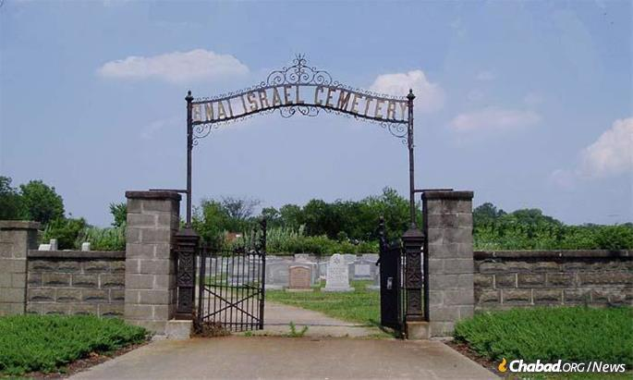

**The Bnai Israel Jewish cemetery in Norfolk, Va.**

“Talk about a [mitzvah](https://www.chabad.org/library/article_cdo/aid/1438516/jewish/Mitzvah.htm),” reflected Suzie, the sole surviving sister (Wendy passed away earlier this year). “I had no idea that my sister had remained in touch with the Adelmans for 35 years, but they kept the connection.”

Following the burial, the funeral party regrouped at Chabad of Tidewater where the mourners were served the traditional meal of [hard-boiled eggs and bread](https://www.chabad.org/library/article_cdo/aid/5280422/jewish/Why-Are-Mourners-Served-Bagels-and-Eggs.htm), and some male family members put on [*tefillin*](https://www.chabad.org/library/article_cdo/aid/1918251/jewish/What-Are-Tefillin.htm).

“I am 50 years old,” says Suzie, “and this is the first Jewish funeral anyone in our family has ever attended. I cried and cried before the funeral, but not afterward, because my sister’s soul is at peace. Candice would be dancing if she knew how things turned out.”

And the Jewish soul of Shoshana bat Yosef was thus escorted to its heavenly abode with full honor and dignity.

*Reprinted from the July 26, 2022 website of Chabad.Org Magazine.*